BANK LOAN REPORT QUERY DOCUMENT
BANK LOAN REPORT | SUMMARY
KPI’s:
Total Loan Applications
SELECT COUNT(id) as total_loan_application from financial_loan;
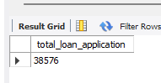
MTD Loan Applications
SELECT COUNT(id) AS MTD_total_loan_application
FROM financial_loan
WHERE STR_TO_DATE(issue_date, '%d-%m-%Y') >= '2021-12-01'
AND STR_TO_DATE(issue_date, '%d-%m-%Y') < '2022-01-01';
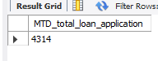
PMTD Loan Applications (MoM)
SELECT COUNT(id) AS PMTD_total_loan_application
FROM financial_loan
WHERE STR_TO_DATE(issue_date, '%d-%m-%Y') >= '2021-11-01'
AND STR_TO_DATE(issue_date, '%d-%m-%Y') <= '2021-11-30';
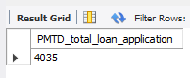
Total Funded Amount
select sum(loan_amount) as total_funded_amount from financial_loan;
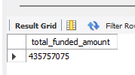

MTD Total Funded Amount
SELECT sum(loan_amount) AS MTD_total_funded_amount
FROM financial_loan
WHERE STR_TO_DATE(issue_date, '%d-%m-%Y') >= '2021-12-01'
AND STR_TO_DATE(issue_date, '%d-%m-%Y') < '2022-01-01';
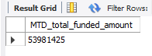
PMTD Total Funded Amount
SELECT sum(loan_amount) AS PMTD_total_funded_amount
FROM financial_loan
WHERE STR_TO_DATE(issue_date, '%d-%m-%Y') >= '2021-11-01'
AND STR_TO_DATE(issue_date, '%d-%m-%Y') <= '2021-11-30';
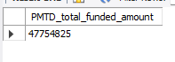
Total Amount Received
select sum(total_payment) as total_amount_received from financial_loan;
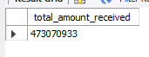
MTD Total Amount Received
SELECT sum(total_payment) AS MTD_total_amount_received
FROM financial_loan
WHERE STR_TO_DATE(issue_date, '%d-%m-%Y') >= '2021-12-01'
AND STR_TO_DATE(issue_date, '%d-%m-%Y') < '2022-01-01';
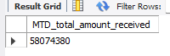
PMTD Total Amount Received
SELECT sum(total_payment) AS PMTD_total_amount_received
FROM financial_loan
WHERE STR_TO_DATE(issue_date, '%d-%m-%Y') >= '2021-11-01'
AND STR_TO_DATE(issue_date, '%d-%m-%Y') <= '2021-11-30';
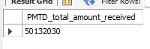
Average Interest Rate
select avg(int_rate)*100 as avg_interest_rate from financial_loan;
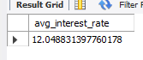
MTD Average Interest
SELECT avg(int_rate)*100 AS MTD_avg_interest_rate
FROM financial_loan
WHERE STR_TO_DATE(issue_date, '%d-%m-%Y') >= '2021-12-01'
AND STR_TO_DATE(issue_date, '%d-%m-%Y') < '2022-01-01';
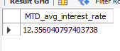
PMTD Average Interest
SELECT avg(int_rate)*100 AS PMTD_avg_interest_rate
FROM financial_loan
WHERE STR_TO_DATE(issue_date, '%d-%m-%Y') >= '2021-11-01'
AND STR_TO_DATE(issue_date, '%d-%m-%Y') <= '2021-11-30';
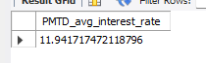
Avg DTI
select avg(dti)*100 as avg_dti from financial_loan;
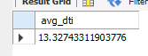
MTD Avg DTI
SELECT avg(dti)*100 AS MTD_avg_dti
FROM financial_loan
WHERE STR_TO_DATE(issue_date, '%d-%m-%Y') >= '2021-12-01'
AND STR_TO_DATE(issue_date, '%d-%m-%Y') < '2022-01-01';
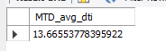
PMTD Avg DTI
SELECT avg(dti)*100 AS PMTD_avg_dti
FROM financial_loan
WHERE STR_TO_DATE(issue_date, '%d-%m-%Y') >= '2021-11-01'
AND STR_TO_DATE(issue_date, '%d-%m-%Y') <= '2021-11-30';
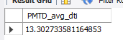

GOOD LOAN ISSUED
Good Loan Percentage
SELECT COUNT(*) * 100.0 / (SELECT COUNT(*) FROM financial_loan) AS Good_Loan_Percentage
FROM financial_loan
WHERE loan_status IN ('Fully Paid', 'Current');
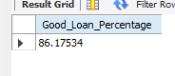
Good Loan Applications
select count(id) as total_good_loan_application from financial_loan
where loan_status IN ('Fully Paid', 'Current');
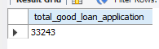
Good Loan Funded Amount
select SUM(loan_amount) as total_good_funded_amount from financial_loan
where loan_status IN ('Fully Paid', 'Current');
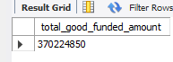

Good Loan Amount Received
select SUM(total_payment) as total_good_amount_received from financial_loan
where loan_status IN ('Fully Paid', 'Current');
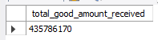
BAD LOAN ISSUED
Bad Loan Percentage
select count(*)*100/
(select count(*) from financial_loan) as bad_loan_percentage
from financial_loan
where loan_status = "Charged off";
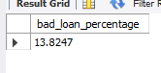
Bad Loan Applications
select count(id) as bad_loan_application from financial_loan
where loan_status = "Charged off";
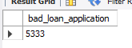
Bad Loan Funded Amount
select sum(loan_amount) as bad_loan_funded_amount from financial_loan
where loan_status = "Charged off";
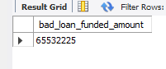
Bad Loan Amount Received
select sum(total_payment) as bad_loan_amount_received from financial_loan
where loan_status = "Charged off";
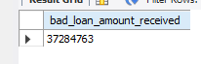

LOAN STATUS
select
loan_status,
count(id) as loancount,
sum(loan_amount) as total_funded_amount,
sum(total_payment) as total_amount_received,
avg(int_rate)*100 interest_rate,
avg(dti)*100 DTI
from financial_loan
group by loan_status;
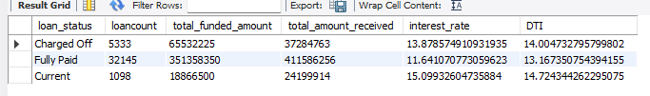
select
loan_status,
sum(loan_amount) as MTD_total_funded_amount,
sum(total_payment) as MTD_total_amount_received
from financial_loan
where str_to_date(issue_date, '%d-%m-%Y') >= '2021-12-01'
and str_to_date(issue_date, '%d-%m-%Y') < '2022-01-01'
group by loan_status;
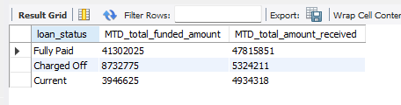
BANK LOAN REPORT | OVERVIEW
MONTH
select
month(str_to_date(issue_date, '%d-%m-%Y')) as monthnumber,
monthname(str_to_date(issue_date, '%d-%m-%Y')) as monthname,
count(id) as total_loan_application,
sum(total_payment) as total_amount_received,
sum(loan_amount) as total_funded_amount
from financial_loan
group by monthnumber, monthname
order by monthnumber asc;
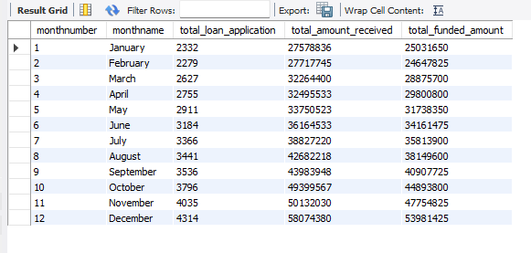
select
address_state,
count(id) as totalcount,
sum(total_payment) as total_amount_received,
sum(loan_amount) as total_funded_amount
from financial_loan
group by address_state
order by address_state asc;
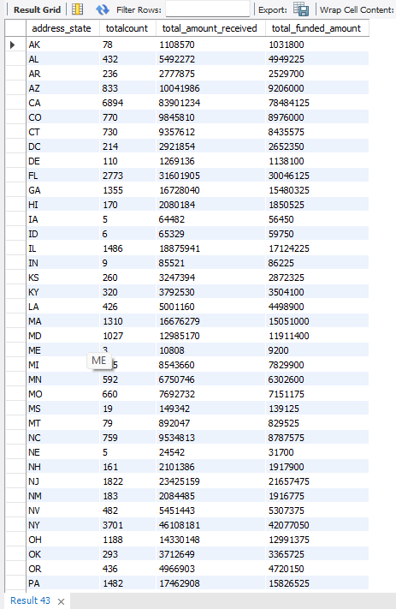
TERM
select term,
count(id) as total_loan_application,
sum(total_payment) as total_amount_received,
sum(loan_amount) as total_funded_amount
from financial_loan
group by term
order by term asc;
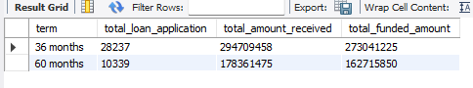
EMPLOYEE LENGTH
select emp_length,
count(id) as total_loan_application,
sum(total_payment) as total_amount_received,
sum(loan_amount) as total_funded_amount
from financial_loan
group by emp_length
order by emp_length asc;
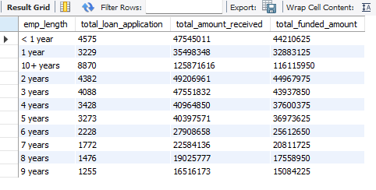
PURPOSE
select purpose,
count(id) as total_loan_application,
sum(total_payment) as total_amount_received,
sum(loan_amount) as total_funded_amount
from financial_loan
group by purpose
order by purpose asc;
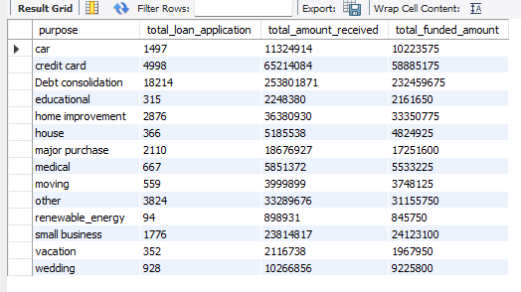
HOME OWNERSHIP
select home_ownership,
count(id) as total_loan_application,
sum(total_payment) as total_amount_received,
sum(loan_amount) as total_funded_amount
from financial_loan
group by home_ownership
order by home_ownership asc;
